**Ayush Kumar 21MCA1117**

**Lab-6**

**1) Write a program to find the average of ‘n’ natural numbers. Use the input through the keyboard during runtime. The program must read the value of n first. If the input n happens to be Zero or negative a suitable User defined Exceptions should be thrown. If it is not possible to convert the input into an integer then NumberFormat Exception must be thrown. After reading n values successfully, we must read the integer values of the array a[]. Each input string must be converted into integer.**

import java.util.*;  
import java.io.*;  
class MyException extends Exception  
{  
public MyException (String str)  
{  
super(str);  
}  
}  
class Exception4{  
static void check(int n)throws MyException{  
if(n<=0){  
throw new MyException("----n should be greater than 0----");  
}  
}  
public static void main(String args[])  
{  
int sum=0;

Scanner sc=new Scanner(System.in);  
System.out.println("Enter number of elements:");  
int n=sc.nextInt();  
try{  
check(n);  
int[] a=new int[n];  
System.out.println("Enter array elements:");  
for(int i=0;i<n;i++)  
{  
a[i]=Integer.parseInt(sc.next());  
}  
System.out.println("Array elements:");  
for(int i=0;i<n;i++)  
{  
System.out.println(a[i]);  
sum=sum+a[i];  
}  
float avg=((float)sum/(float)n);  
System.out.println("Avg of n numbers::"+avg);  
}  
catch(NumberFormatException e)  
{  
System.out.println("Number Format exception");  
}catch(MyException e){  
System.out.println("Exception:"+e);  
}

}  
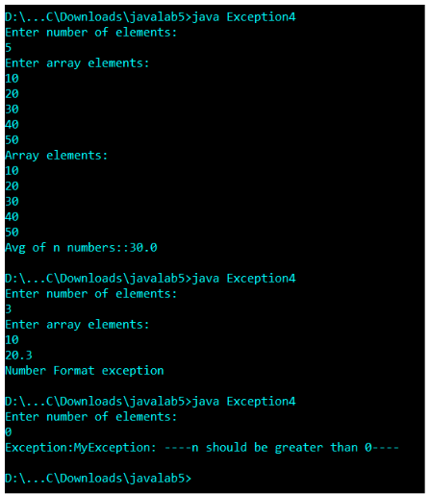}

**2) Write a Java program to check whether the person is eligible to vote in parliament elections using user-defined exception.**

import java.util.*;

import java.io.*;

class MyException extends Exception

{

public MyException (String str)

{

super (str);

}

}

class Exception6

{

static void check (int n) throws MyException

{

if (n < 18)

{

throw new

MyException ("---Voter must be greater than or equal to 18----");

}

else

{

System.out.println ("You are eligible to vote..");

}

}

public static void main (String args[])

{

//int sum=0;

Scanner sc = new Scanner (System.in);

int n = sc.nextInt ();

try

{

check (n);

}

catch (MyException e)

{

System.out.println ("Exception:" + e);

}

}

}

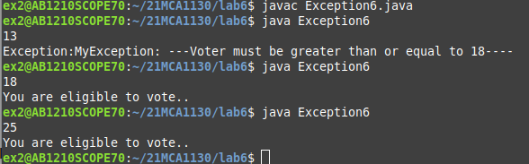

**3) Write a Java program to find factorial value of positive integer otherwise raise an exception using user-defined exception.**

import java.util.*;

import java.io.*;

class MyException1 extends Exception

{

public MyException1 (String str)

{

super (str);

}

}

class Exception7

{

static void check (int n) throws MyException1

{

int sum=1;

if (n < 0)

{

throw new

MyException1 ("....The number should be positive integer....");

}

else

{

System.out.println ("Fine...Proceed->");

for(int i=n;i>1;i--){

sum=sum*i;

}System.out.println("The factorial of the given number is::"+sum);

}

}

public static void main (String args[])

{

Scanner sc = new Scanner (System.in);

System.out.println("Enter number is::");

int n = sc.nextInt ();

try

{

check (n);

}

catch (MyException1 e)

{

System.out.println ("Exception:" + e);

}

/*try{

for(int i=n;i>1;i--){

sum=sum*i;

}System.out.println("The factorial of the given number is::"+sum);

}

catch (Exception e){}*/

}

}

